# Harshini S

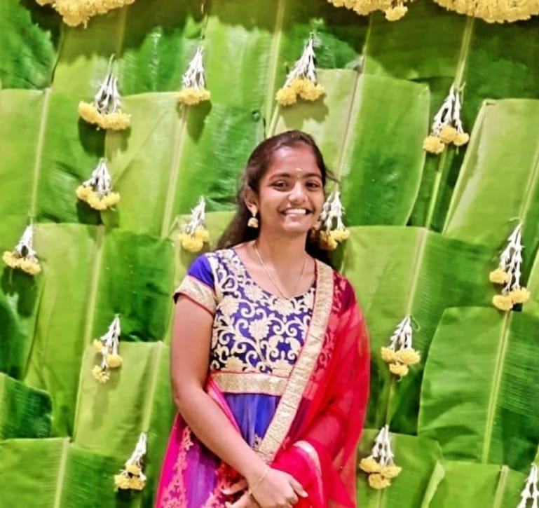

19A, Indira Nagar, Thiruvannamalai

9025868937

200701081@rajalakshmi.edu.in

O B J E C T I V E

I am looking forward to roles that will help me realise my potential by exploring the various aspects of this field.

EDUCATION

**Rajalakshmi Engineering College, Chennai, Tamilnadu**

October 2020 - May 2024

***Bachelor of Engineering in Computer Science***

CGPA: 9.52

P R O J E C T S

* Stress Detection using Data Science and Machine learning
* Café Management System using Netbeans by mySql backend
* Fitness Website named ‘Fittest’ using PHP, JS, Bootstrap

#### ADDITIONAL SKILLS

SKILLS

* Java
* SQL
* NodeJs

Languages

* English
* Tamil

INTERESTS

* Ethical Hacking
* Angular